**Real Case Scenario #2**

This morning, Patrick woke up and attempted to print a file. However, he encountered an error message on his screen stating, “Printer Spooler Service Error.” This issue is preventing him from printing any documents. Given the urgency of his task, Patrick is eager to resolve the problem as quickly as possible. He is willing to assist in troubleshooting and is open to receiving instructions over the phone to fix the issue. Please include all the steps taken through the ticketing system and the entire process carried out.

Serial Number: CN4376S099

**User’s information:**

Name: Patrick A.  
Account ID: 56865897  
Phone Number: +12257896451  
Email: patrick12@comcast.net

**Tools**  
Ticketing System: [Sign in to Zendesk](https://www.zendesk.com/login/)  
HP Website: [Service status](https://support.hp.com/us-en/check-warranty)

**Notification Error**

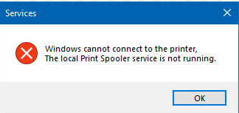 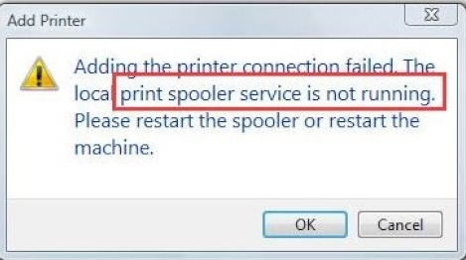

**Possible Causes:**

* Printer spooler service is stopped.
* Corrupted print jobs in the queue.
* Printer driver conflicts.

**Steps to Fix:**

1. **Restart Printer Spooler Service:**
   * Press Win + R to open the Run dialog box.
   * Type services.msc and press Enter.
   * In the Services window, scroll down and find **Print Spooler**.
   * Right-click on **Print Spooler** and select **Restart**.
2. **Clear Print Queue:**
   * Press Win + R to open the Run dialog box.
   * Type services.msc and press Enter.
   * In the Services window, scroll down and find **Print Spooler**.
   * Right-click on **Print Spooler** and select **Stop**.
   * Open File Explorer and navigate to C:\Windows\System32\spool\PRINTERS.
   * Delete all files in the PRINTERS folder.
   * Go back to the Services window, right-click on **Print Spooler**, and select **Start**.
3. **Update Printer Driver:**
   * Go to the printer manufacturer’s website and download the latest driver for your printer model.
   * Install the driver and restart your computer.
4. **Check for Windows Updates:**
   * Go to **Settings** > **Update & Security** > **Windows Update**.
   * Click on **Check for updates** and install any available updates.
5. **Run Printer Troubleshooter:**
   * Go to **Settings** > **Update & Security** > **Troubleshoot**.
   * Select **Printer** and click on **Run the troubleshooter**.
   * Follow the on-screen instructions to identify and fix any issues.
6. **Reinstall Printer:**
   * Go to **Control Panel** > **Devices and Printers**.
   * Right-click on your printer and select **Remove device**.
   * Disconnect the printer from your computer.
   * Restart your computer.
   * Reconnect the printer and follow the prompts to reinstall it.